Exercise 4:

1. Log into the DQ Trainingland instance and launch the WHO Data Quality Tool.
2. Click on the Consistency-Time tab of the dashboard of the WHO Data Quality Tool.
3. Set the dashboard as follows: Data = [Core]; Period = April 2020; Organisation Unit Boundary = National; Disaggregation = District.
4. 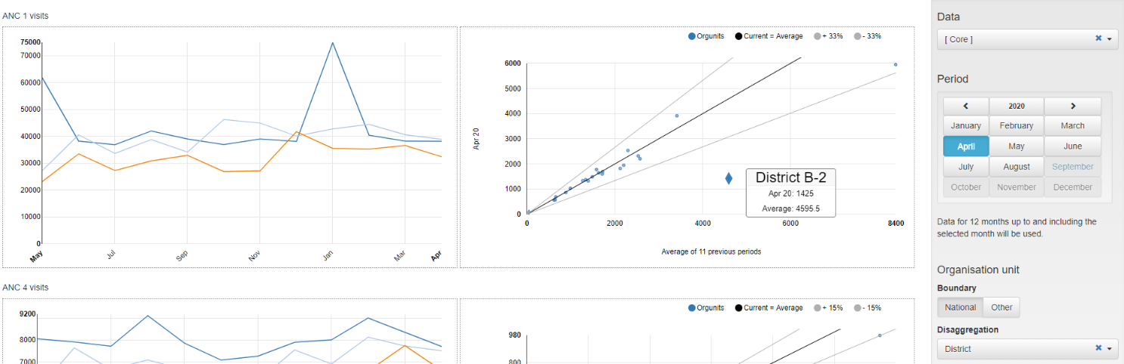Review the two charts for ANC 1 visits. Place the cursor over the outlier value for the diamond-shaped dot of the chart on the right. Question 4-1: The dot is for which district?

1. Use the settings window to review the data for this district.
   1. Click on Other.
   2. Click on the + sign to the left of Region B
   3. Click on and select district B-2.
   4. Wait for the screen to refresh.

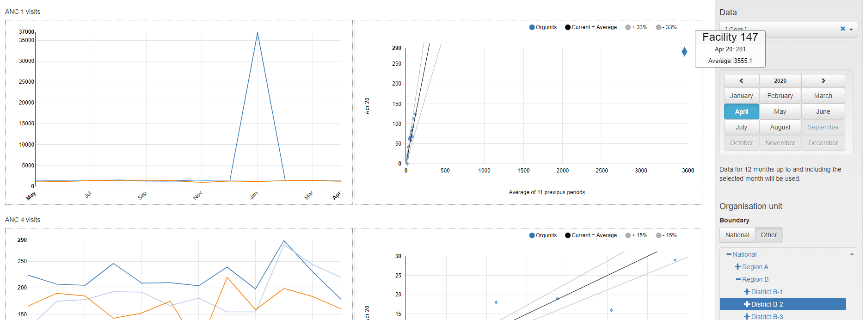

1. Review the chart on the left. Question 4-2: Explain why the chart now looks this way: a triangle on top of a single, straight, horizontal line.
2. Place the cursor over the diamond-shaped dot of the scatterplot on the right. Question 4-3: Which health facility reported the extreme outlier value seen in the chart on the left? During which month was this outlier value reported? For this facility, why was the average for the previous 11 months so much higher than the value for April 2020?
3. Change Period to January 2020. Place the cursor over the diamond-shaped dot of the scatterplot on the right. Question 4-4: Which health facility reported the extreme outlier value of the chart on the left? What is the outlier value reported by this health facility?

Answers:

Question 4-1: The dot is for district B-2

Question 4-2: Most months the number of ANC 1 visits was close to 1,300. In January 2020, however, the value was very much greater (36,835). This January 2020 value is so much greater than the values for the other months that the graph looks like a triangle on top of a straight-line.

Question 4-3: The diamond-shaped dot represents facility 147 which reported 281 for April 2020 but had an average value of 3,551 over the 11 months prior to April 2020. This facility reported the outlier in January 2020. Due to this January value, the average for the 11 months prior to April 2020 is very high.

Question 4-4: 35,888 ANC 1 visits are recorded for facility 147 for January 2020.